Fibres and Fabrics

- Materials for Clothing and Textiles
- clothes and textiles can be made from different materials
- most of them are made from fabrics which are composed of a variety of fibres
- generally, types of fibres are classified based on their sources
- there are three main groups of fibre: natural fibre, regenerated fibre and man-made fibre

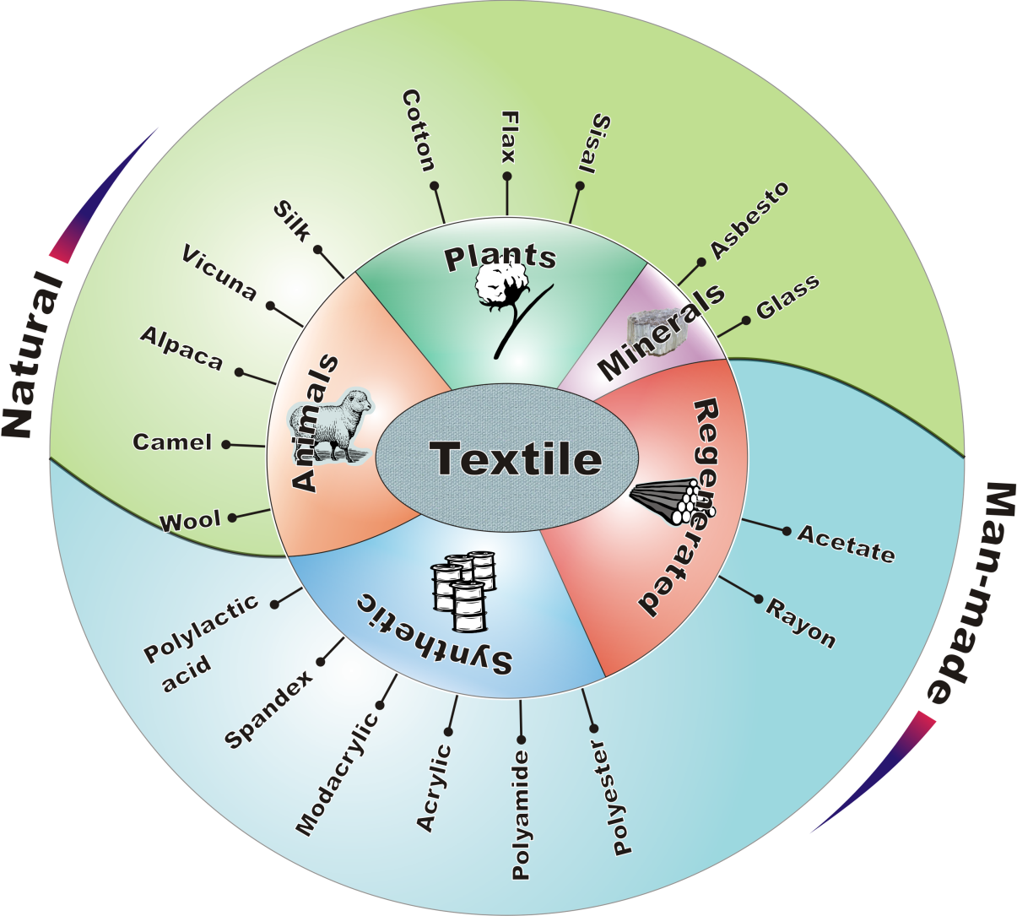

- natural fibres
- plants
- cotton
- cotton fibres are seeds hair
- very fine fibre, flattened tube like thread
- Sea-Island cotton is the longest cotton fibre and Asian cotton is the shortest
Fibre identification: burning test | - burns quickly with afterglow  - smells like burnt paper  - pale grey residue and powdery ash
Properties | - strong and durable  - poor elasticity and creases easily  - can be damaged by strong acids
Clothing comfort | - cool to wear  - good moisture absorption  - dries slowly
After care | - can be boiled and ironed at high temperature  - may shrink
Typical fabric | - calico, corduroy, denim, gingham, drill, terry toweling
- flax / linen
- fibres are extracted from the stalks
- coarse fibre bundle, cylindrical shape with nodes / joints
Fibre identification: burning test | - burns quickly with afterglow  - smells like burnt paper  - pale grey residue with powdery ash
Properties | - very strong fibre and durable, even stronger when wet  - brittle and poor in flexibility  - creases badly  - can be damaged by strong acids
Clothing comfort | - cool to wear  - absorbs water quickly and fast drying
After care | - can be boiled and ironed at high temperature  - may shrink

- animals
- wool
- wool is a kind of animal fibre taken from fleece of sheep and goats
- wool fibre is light, ranges from fine to coarse, surface with overlapping scales and crimps
- the finest and softest wool comes from Merino sheep
Fibre identification: burning test | - small and sputtering flame, self-extinguishing  - smells like burning hair  - black residue with friable cinder
Properties | - medium strength and not very durable  - excellent resilience  - felting occurred when affected by heat and moisture  - weakened by alkalis and damaged by chlorine bleach
Clothing comfort | - warm to wear  - good moisture absorption  - water repellent
After care | - will shrink and felt  - cannot be bleached by chlorine bleach  - iron at moderate temperature  - do not tumble dry or dry in direct sunlight
Typical fabric | - felt, tweed, gabardine  - Woolmark, Woolmark Blend, Wool Blend
- hair
- hair fibres possess similar structure and properties as wool
- the care of hair fibres is also very similar to that of wool
- hair fibres include camel hair, mohair, cashmere, alpaca, llama, vicuna and angora (rabbit hair)
- silk
- silk is obtained from cocoons of silkworm larvae
- silk is triangular in cross-section with round corners, smooth and rod like surface with some striations
Fibre identification: burning test | - small flame, slowly self-extinguishing  - smells like burning hair or horn  - black residue with friable cinder
Properties | - strong, durable, light and elastic  - weakened when wet  - fairly crease-resistant  - damaged by alkaline and chloride bleach
Clothing comfort | - both cool and warm  - good moisture absorption
After care | - wash with gentle detergents with minimum agitation and cool rinse  - cannot be bleached by chlorine bleach  - do not tumble dry or dry in direct sunlight  - iron with dry iron at low temperature
Typical fabric | - chiffon, crepe, satin, voile

- regenerated fibres
- the basic principle of producing regenerated fibres is the dissolution of cellulose and the regeneration of fibres through fibre spinning
- the process produces filament yarns which can be chopped into staple to imitate natural fibres
- recently, renewable resources such as bamboo are used for regenerated fibre production
- acetate
- acetate is made from cotton linters
- acetate is white fibre with longitudinal, striations and irregular cross-section
Fibre identification: burning test | - burns quickly and melts in a flame  - with an acidic smell  - with hard and black residue
Properties | - low strength, even weaker when wet  - poor elasticity  - creases and shrink easily  - melts at high temperature
Clothing comfort | - not very warm  - low moisture absorption  - fast drying
After care | - sensitive to dry heat  - do not bleach and tumble dry
Typical fabric | - brocade, satin, taffeta

- viscose rayon
- viscose rayon is made from wood pulp
- viscose rayon is white, lustrous fibre with irregular cross section
Fibre identification: burning test | - burns quickly with bright flame and afterglow  - smells like burning paper  - with pale grey powdery ash
Properties | - lower strength and durability than cotton  - poor elasticity  - shrink and creases easily  - degraded by acids and alkalis  - melts at high temperature
Clothing comfort | - cool to the touch  - good moisture absorption
After care | - wash in warm water  - iron at low temperature  - do not bleach and tumble dry
Typical fabric | - lustrous and crepe fabric  - cotton, linen, silk and wool-like fabric

- synthetic fibres
- synthetic fibres refer to fibres obtained from petroleum
- new fibres have evolved based on chemicals extracted from corn, sugar beet, soya bean, etc
- polyester
- polyester is white fibre with different cross sections - round, tri-and multilobal, oval and hollow
Fibre identification: burning test | - melts and shrinks from the flame  - forms a brownish mass  - hard and uncrushable residue
Properties | - good strength and durable  - good elasticity and crease resistant  - melt at high temperature
Clothing comfort | - poor moisture absorption  - fast drying
After care | - wash in warm water  - do not bleach  - iron at low temperature

- nylon
- nylon is transparent and resembles a glass rod with round cross section
Fibre identification: burning test | - shrinks and melts away from flame with fibre-forming drips  - hard and uncrushable residue
Properties | - very strong and durable  - good elasticity and wrinkle resistant  - melts at high temperature  - affected by concentrated acids and sunlight
Clothing comfort | - poor moisture absorption  - windproof and water repellent
After care | - wash in cool water  - do not bleach and tumble dry  - iron at low temperature
Typical fabric | - Nylon 6, Nylon 6,6
- acrylic
- acrylic fibre is commonly used as wool substitute as its resilient resembles to that of wool but without felting and shrinkage tendency
- acrylic fibres crimp with striations and may be smooth or twisted surface
Fibre identification: burning test | - shrinks and burns with a sooty flame  - with melting, dripping and forms black beads  - pungent smell  - hard and unbreakable residue
Properties | - strong and durable when compare with cotton and wool  - moderate elasticity and wrinkle resistant  - melts at high temperature
Clothing comfort | - warm, insulating qualities similar to wool  - low absorbency  - fast drying  - prone to static
After care | - wash in cool water  - iron at low temperature
Typical fabric | - usually blended with other fibres, such as cotton, linen, viscose rayon, wool and silk

- Ways to Produce New Textile Materials – Blending
- blending is mix two or more fibres together
- the advantage of fibre blending is that poor properties of one component can be compensated by good ones of the other component
- e.g. some natural fibres shrink and wrinkle after laundering, blending with man-made fibres can reduce shrinkage and wrinkle of natural fibres

- Fabric Construction
- fabric is constructed from yarns
- yarns are threads which are made from smaller threads
- fabrics are readily made materials for the production of various kinds of textile products
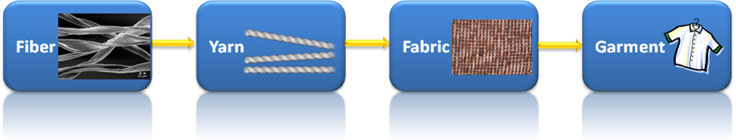

- woven fabrics
- woven fabrics are made from interlacing two sets of yarns at a right angle
- the process is called weaving
- yarns parallel to length are called warps
- yarns parallel to width are called wefts

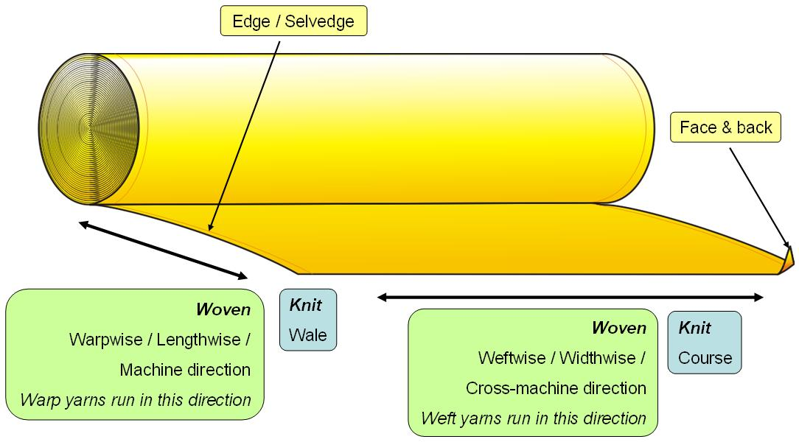

Plain weave | 2/1 S-twill | 2/2 Z-twill
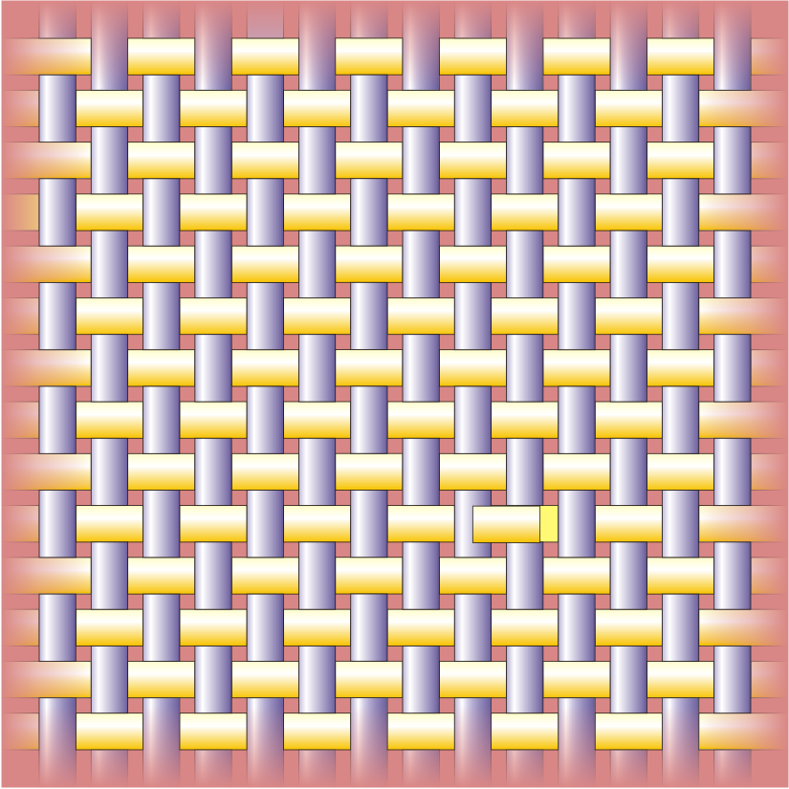 | 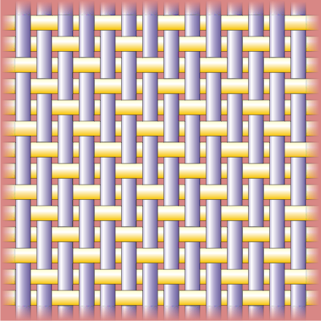 | 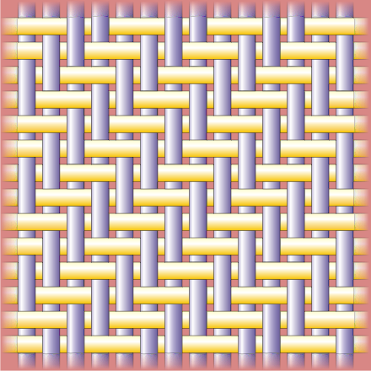
Poplin | satin | sateen
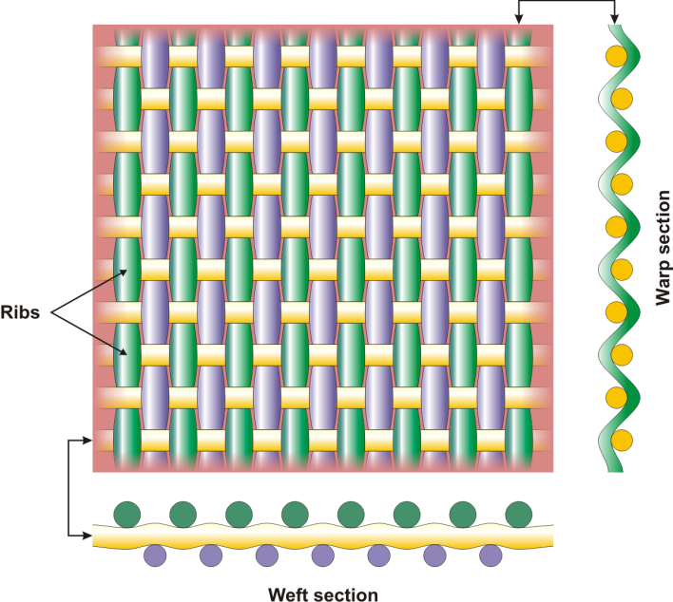 | 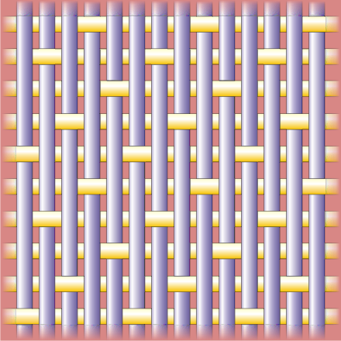 | 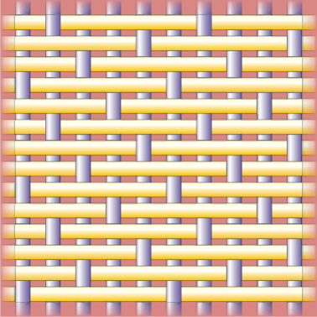
- knitted fabrics
- knitted fabrics are formed by interlocking yarn loops
- the process is called knitting
- the direction is called course
- the direction parallel to length is called wale
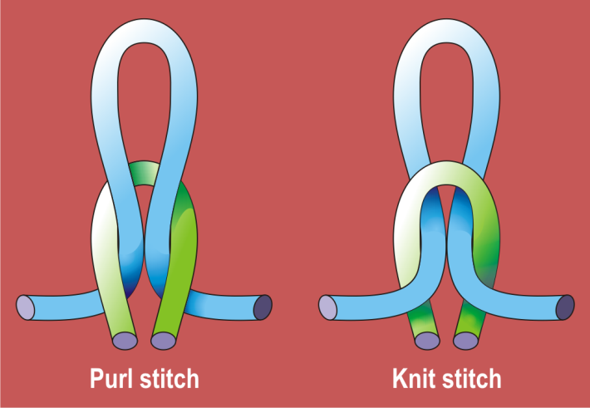

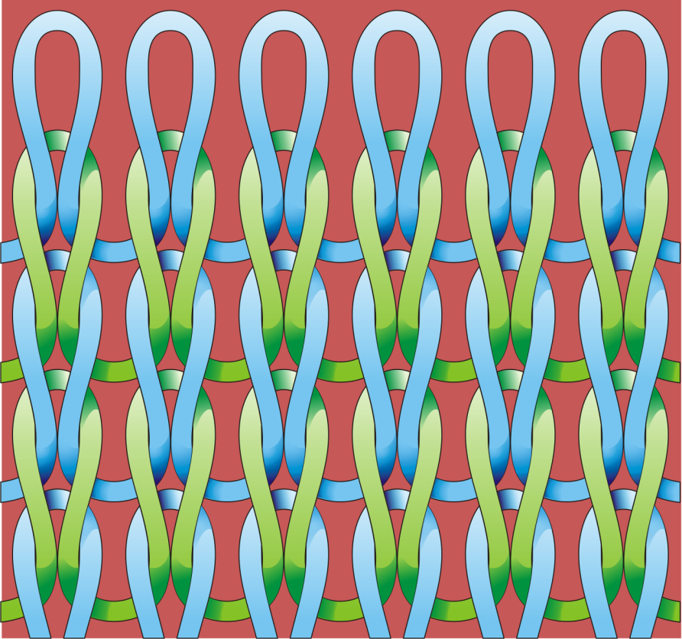
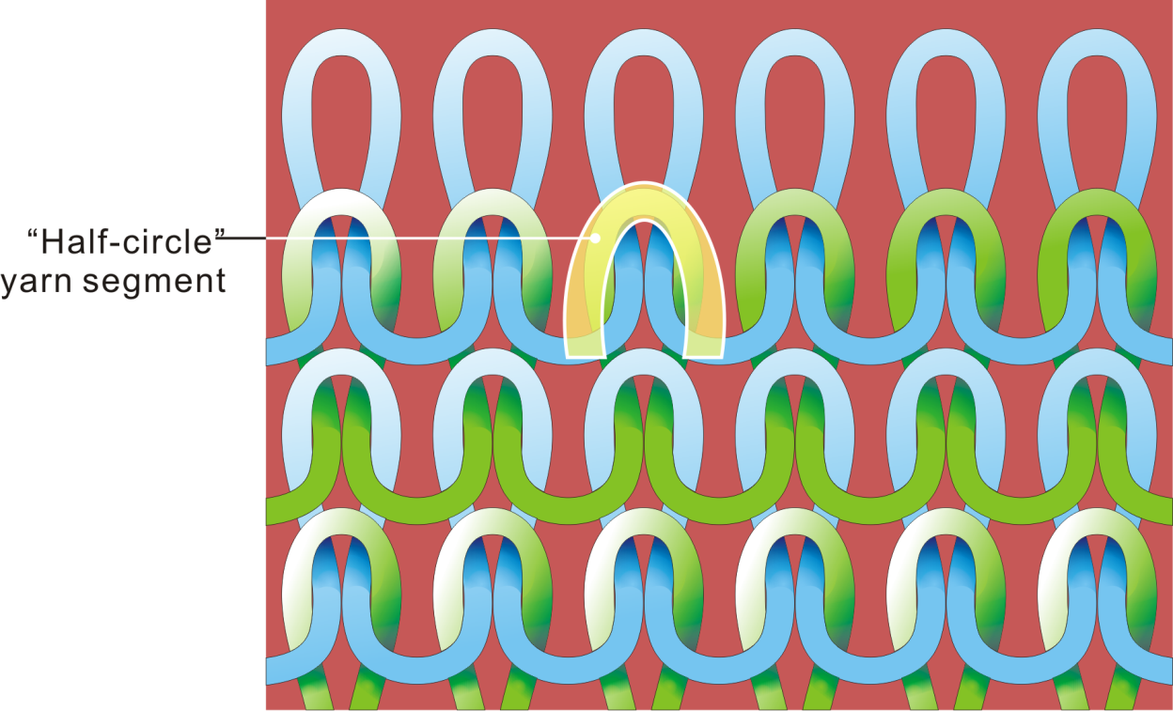

Front Side Back Side
- non-woven fabrics
- the formation of non-woven fabrics is by compressing fibres together through:
- mechanical bonding
- glue
- heat fusion

4. Colouration
(a) dyeing
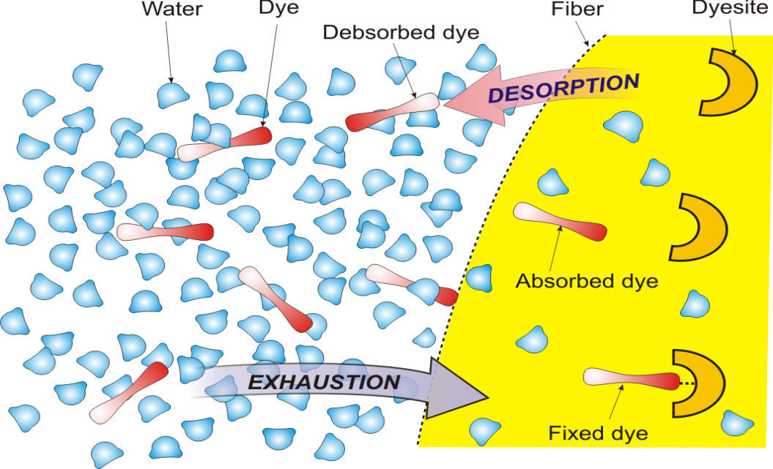

(b) printing

Flatbed screen printing | Rotary screen printing
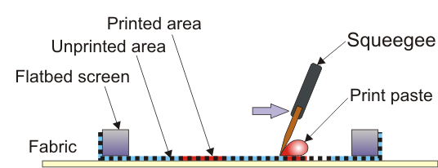 | 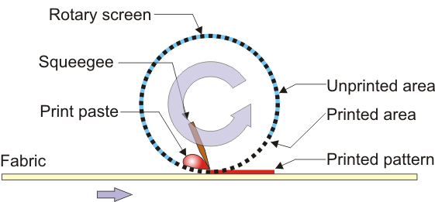

5. Finishing
(a) mechanical finishing
- raising
- calendaring
- embossing
- fulling
(b) chemical finishing
- water repellency
- water proofing
- stain resistance
- antibacterial finishing
- antistatic finishing
- nanotechnology (e.g. stain proof finishing, antimicrobial finishing, odorless textile, fragrance release finishing, skin care finishing)

